TOPIC 5.6 : DIJKSTRA'S ALGORITHM USING EDGE LIST
Problem Statement
Given a graph represented by an edge list, implement Dijkstra's Algorithm to find the shortest path from a given source vertex to a target vertex.
The graph is represented as a list of edges where each edge is a tuple (u, v, w) representing an edge from vertex u to vertex v with weight w.
Test Case 1
Input:
n = 6
edges = [(0, 1, 7), (0, 2, 9), (0, 5, 14), (1, 2, 10), (1, 3, 15), (2, 3, 11), (2, 5, 2), (3, 4, 6), (4, 5, 9)]
source = 0
target = 4
Output: 20
Test Case 2
Input:
n = 5
edges = [(0, 1, 10), (0, 4, 3), (1, 2, 2), (1, 4, 4), (2, 3, 9), (3, 2, 7), (4, 1, 1), (4, 2, 8), (4, 3, 2)]
source = 0
target = 3
Output: 8
Aim
To write a program that finds the shortest path distance from a given source vertex to a target vertex using Dijkstra's Algorithm with an edge list representation of a graph.
Algorithm
- Start
- Build an adjacency list from the edge list
- Initialize distance array with Infinity, set distance[source] = 0
- Use a priority queue (min-heap) to pick the vertex with the smallest distance
- For each neighbor v of u with weight w:
If dist[u] + w < dist[v], update dist[v] and push it into the heap
- Repeat until all vertices are processed or target is reached
- Return dist[target]
- Stop
Input and Output
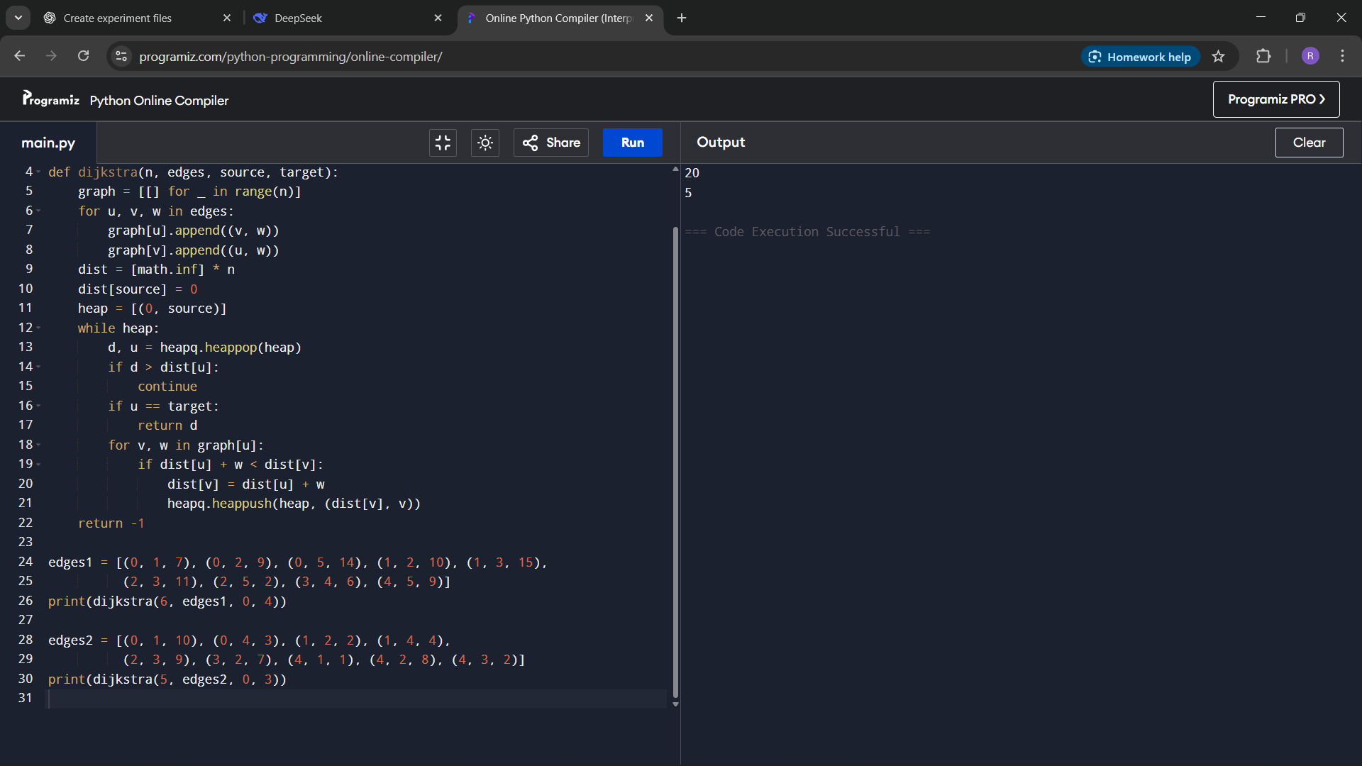
Result
The program successfully computes the shortest path distance between source and target using Dijkstra's Algorithm on an edge list.
Performance Analysis
Time Complexity: O((V + E) log V) using a priority queue
Space Complexity: O(V + E) for adjacency list and heap

